US GLOBEC Pan-Regional Synthesis Workshop
27-30 November 2006
NCAR Center Green Facility, Boulder CO

Working Groups #1 (11/28/2006)

Pan-regional cross-cut by trophic levels:
Circulation/Phytoplankton Production/Zooplankton group

What are the opportunities for Pan-Regional Synthesis that can be answered by comparing and contrasting systems?

Chair: Jeffrey Runge; Rapporteur: David Mountain

Participants: James Bisagni, Ric Brodeur, Ann Bucklin, Kendra Daily, Cabell Davis, Christian Fritsen, Al Hermann, Zack Powell, Robin Ross, Beth Turner, Peter Wiebe

The Chair recommended that the group address its task by working through the questions one at a time. It was recommended that pages 54-58 of the Pan Regional Synthesis document by Mike Fogarty be used as a reference. The questions are addressed here in the order they were discussed

What have we learned? What models (or other approaches to synthesis) exist, or are needed, and of what type?

For modeling the pelagic ecosystem, the rhomboid or middle-out approach (de Young et al. 2004) offers a way to deal with the complexity of interactions from physics to phytoplankton to zooplankton and ichthyoplankton, including characterization of the life histories of the individual key species in the higher trophic levels. Within each region, this approach would include a physical circulation model coupled to an NPZD model. The output of this (prey availability in space and time) would then be used as input to a coupled physical- ZLCM model (zooplankton life cycle model). The output from the coupled ZLCM model (zooplankton prey fields) would provide input to a coupled physical-larval fish trophodynamic or other higher topic level model. The NPZD models are Eulerian and concentration based. The larval fish/higher trophic level models are Lagrangian and IBM. The intermediate zooplankton model could be either Eulerian/concentration or Lagrangian/IBM (Figure 1).

When the GLOBEC program began, neither the approach nor the modeling capability existed. It represents a major advance that the approach has been ‘learned’ through the program. Using this approach does require fairly specific knowledge of the various trophic levels and an important consideration – also addressed below – is how much simplification is necessary and/or appropriate.

Each region has the capability to undertake this approach. There are differences between regions in how this modeling approach is implemented for synthesis. For example, in the Antarctic the physical model will include a coupled ocean-ice component and for the biology the top predators will be more of a focus than in the other projects. In the northeast Pacific, the zooplankton (Pseudocalanus) population dyanamics is dynamically embedded in the NPZ model.

In the modeling activities currently being done, the coupling between the rhomboids generally is in one direction, from lower to higher levels. There is not included a feedback from an upper trophic level, IBM model to the NPZD model. There may be situations where this type of two-way coupling would prove valuable. An issue to be addressed during synthesis will be determining the advantages and/or necessity of having a fully coupled set of models.

IMBER intends to have a large effort in model development. Depending upon the timing, IMBER’s effort may contribute to GLOBEC’s modeling needs (especially for development of NPZ models including microzooplankton), or GLOBEC’s efforts may contribute to IMBER (especially for characterization of individual key species).

In more general terms of what has been learned, it will be useful for each region to identify ideas or concepts that were thought to be ‘conventional wisdom’ at the beginning, but through the program results have been shown to be inaccurate.

How does climate influence the variability of recruitment in these systems?

The U.S. GLOBEC programs have focused on climate forcing through bottom up processes, and the approach of linked coupled models described above can address climate influences on recruitment processes.The effects of climate change enter primarily through advection, as opposed through direct, local influence. In the NEP the large scale climate models do capture the changes and deliver them to the coastal region. For Georges Bank the ability of the large scale models to represent the observed changes (e.g., the low salinity event which appears to have originated at high latitude) is not yet clear. On the biological side it will be important to determine whether the biological response to the climate variability also is advected into the region or occurs through local biological processes responding to the advected physical changes.

.There was general consensus that we do have the knowledge and the approaches to answer the effect of climate forcing on recruitment of the target species.

What are the critical characteristics that make these species useful for PRS?

The group felt that this question needed to be restated as: What evidence do we have that knowledge of the life history characteristics and physiological attributes of the individual species is essential to understanding the ecosystem dynamics?

It will be important to determine how much simplification in the life history can be done and still represent the population and ecosystem dynamics. Related questions are:

How can we use the individual species life history information to give us a comprehensive understanding of ecosystem dynamics? This point also applies to modeling issues discussed above.

Can/must we ultimately deal with functional groups of species or will keeping a focus on the identified target species be sufficient? For examination of full ecosystem dynamics, the answer to the latter question is no. The target species may be good to indicate climate sensitivity, but in some cases they are not as critical to the ecosystem as other species, i.e. there are more key species than initially targeted by the GLOBEC.

A fundamental aspect of a species population dynamics that has not been addressed determining knowing what processes or characteristics limit the range of a species. Can we derive and predict distributional limits from our models?

In terms of the rhomboid modeling how much do we need to know about the prey of a target species to successfully model its dynamics? If the prey is sensitive climate change, then including that sensitivity will be important.

Where are the data gaps? How might they be filled with existing data taken in other programs?

The group did not have much time to spend on this question. However a number of data gaps were identified for all of the regions
:
Information on many microbial components
Nutrient data
Information on non-target species (e.g., pteropods)

Existing data does exist from other programs, but it will be limited.

The overarching question: What are the opportunities for Pan-Regional Synthesis that can be answered by comparing and contrasting systems?
.
There are a number of characteristics of the systems that can be compared and contrasted as a basis for Pan-Regional Synthesis:

- Climate forcing mechanisms, for example freshwater effects on density driven circulation and stratification; effects of winds on mixing and on transport of zooplankton and ichthyoplankton. All of the regions have climate forcing issue related to fresh water sources; in the northwest Atlantic, the freshwater forcing is "remote" (originating in the Arctic) whereas they are "local" (melting of glaciers and river discharge) in the Northeast Pacific. For Georges Bank the important wind forcing is mainly local, while for the NEP the important winds are associated with the large scale atmospheric pattern.

- Model approaches: There are common, important and non-trivial technical issues concerned with linking the coupled models (e.g. the prey field output from an NPZ model to a zooplankton life history model). Approaches to model validation with data is also a common pan-regional issue.

- Similarities and differences in life history strategies in response to forcing; for example copepod dormancy responses among species and regions.

- Similarities in geomorphology; eg. The Antarctic and the Gulf of Maine/Georges Bank have much in common in their geomorphology (size and topographic features). GB and Antarctica translate into similarities in forcing and ecosystem responses?

- Georges Bank has physical and biological mechanisms promoting retention, while the California Current is more directly a flow through system.

- The physical and biological processes driving good and bad recruitment of the target organisms can be compared and contrasted between the regions

An important issue discussed by the group on which a consensus was not reached was what expectations should we have for Pan-Regional Synthesis in relation to addressing the population dynamics of the target organisms in a changing climate vs addressing ecosystem dynamics in a changing climate. We need to live up to the goals set out for the program, but not to redefine those goals upward as we approach the end. While we have approaches and detailed knowledge to answer questions of climate forcing on recruitment of the target species, we also need to identify during synthesis how our knowledge can be applied to the broad question of climate forcing on ecosystem and function. To what extent can target species responses represent ecosystem structure and function? Will inclusion of other species now identified as key functional components be sufficient? How much simplification can we re-introduce? A quote from GLOBEC report 6 seemed to capture the relationship between the focus on the population dynamics of the target organisms and the expectations for ecosystem level implications. This issue should be reviewed carefully when the Announcement of Opportunity for Pan-Regional Synthesis is being drafted.

References
deYoung, B., M. Heath, F. Werner, F. Chai, B. Megrey and P. Monfray. 2004. Challenges of modeling ocean basin ecosystems. Science 304: 1463-1466.

Runge, J. A., Franks, P. J. S., Gentleman, W. C., Megrey, B. A., Rose, K. A., Werner, F., E., Zakardjian, B., 2005. Diagnosis and prediction of variability in secondary production and fish recruitment processes : developments in 12 physical-biological modeling. In: The Sea. John Wiley & Sons, New York.
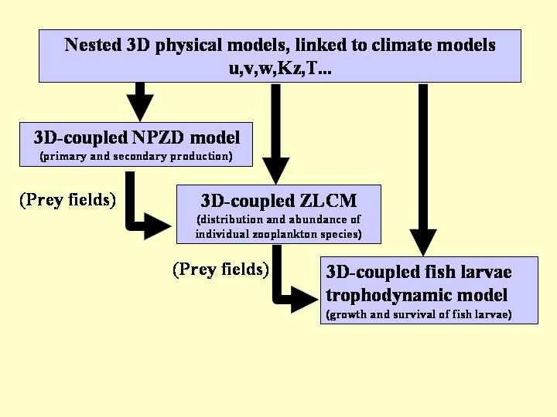

Figure 1. Middle out model approach for analysis of climate forcing on phytoplankton, zooplankton and ichthyoplankton. Shown is a system of linked coupled models in which population dynamics of target species are parameterised in detail, linked to lower resolution models of describing prey and predator abundance (adapted from Runge et al. 2005).

